Business Question and Visualization Report
Team ID | MCA
Project Name | Smartphone Usage, Digital Addiction & Well-being Analytics
Maximum Marks | 5 Marks

Visualization Development
Visualization development refers to the process of converting data into graphical and interactive formats that make patterns, comparisons, and relationships easier to understand. In this smartphone usage analysis, Power BI visuals are used to examine screen time, addiction levels, age groups, gender, sleep, gaming, social-media activity, notifications, and app usage. The objective is to transform the dataset into clear business questions and actionable observations.
Business Questions and Visualisation
The following eight business questions are based on the provided Power BI dashboard screenshots. Each question is linked to an appropriate visualization and a short interpretation of the values visible in the dashboard.
1. What is the overall profile of smartphone users in the dataset?
- Visualization: KPI cards showing total users, average age, average daily screen time, and average sleep hours.
- Key insight: The dashboard contains 7,500 users. The average age is 26.57 years, average daily screen time is 7.50 hours, and average sleep time is 6.74 hours.
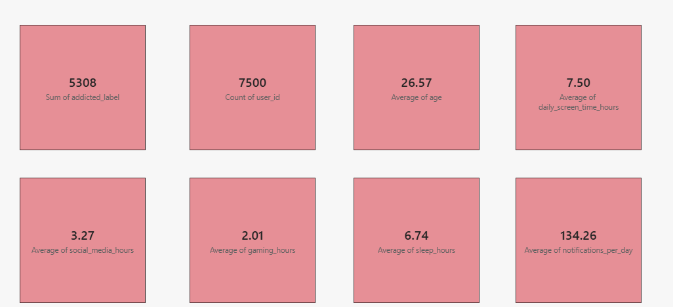
2. How does average daily screen time vary by gender?
- Visualization: Column chart comparing average daily screen time for Male, Other, and Female users.
- Key insight: Average screen time is very similar across the three gender groups, remaining around 7.4–7.6 hours per day.
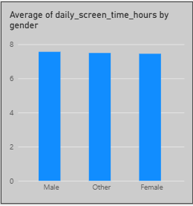
3. Which addiction levels have the highest number of users?
- Visualization: Horizontal bar chart showing the count of users by addiction level.
- Key insight: Moderate addiction has the largest count, followed by Severe addiction. Mild and None have lower counts in the displayed dataset.
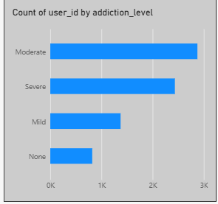
4. How does average daily screen time vary across age groups?
- Visualization: Column chart comparing average daily screen time for Under 20, 20–29, and 30–39 age groups.
- Key insight: The three age groups show very similar average daily screen time, with values close to 7.4–7.6 hours.
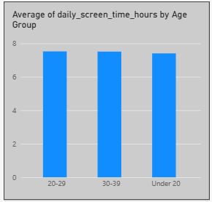
5. What is the relationship between daily screen time and sleep hours?
- Visualization: Scatter plot comparing daily screen time hours with sleep hours for individual users.
- Key insight: The scatter plot shows the distribution of users across screen-time and sleep-hour values. It can be used to identify patterns or clusters between the two measures.
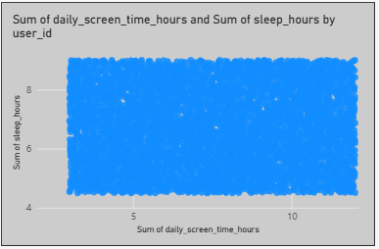
6. What proportion of users are classified as addicted?
- Visualization: Donut chart showing the count and percentage of users by addicted_label.
- Key insight: The dashboard shows about 5.31K users (70.77%) with addicted_label = 1 and about 2.19K users (29.23%) with addicted_label = 0.
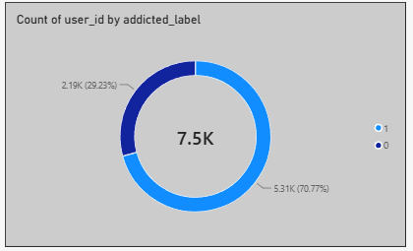
7. How do average gaming hours compare with average social-media hours?
- Visualization: Clustered column chart comparing average gaming hours and average social_media_hours.
- Key insight: Average social-media usage is about 3.27 hours, while average gaming usage is about 2.01 hours per day. Social-media usage is therefore higher in the displayed averages.
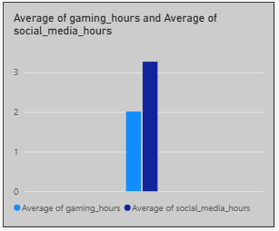
8. What are the average daily engagement and usage indicators?
- Visualization: KPI cards showing average notifications, app opens, weekend screen time, social-media hours, gaming hours, and work/study hours.
- Key insight: The dashboard reports 134.26 notifications per day, 97.83 app opens per day, 9.24 hours of weekend screen time, 3.27 social-media hours, 2.01 gaming hours, and 3.24 work/study hours on average.

Conclusion
The Power BI dashboard provides a consolidated view of smartphone usage and addiction-related behavior across 7,500 users. The visuals highlight high average screen time, differences in addiction levels, the distribution of addicted versus non-addicted users, and the relationship between smartphone activity and lifestyle measures such as sleep and work/study time. These visualizations make the dataset easier to interpret and support further analysis of smartphone usage patterns.

